  
5 Aug. 2021

Team 12: Liver Pan Star

Desktop and Keyboard Desktop Dust Cleaner Based on Axial-flow Fan 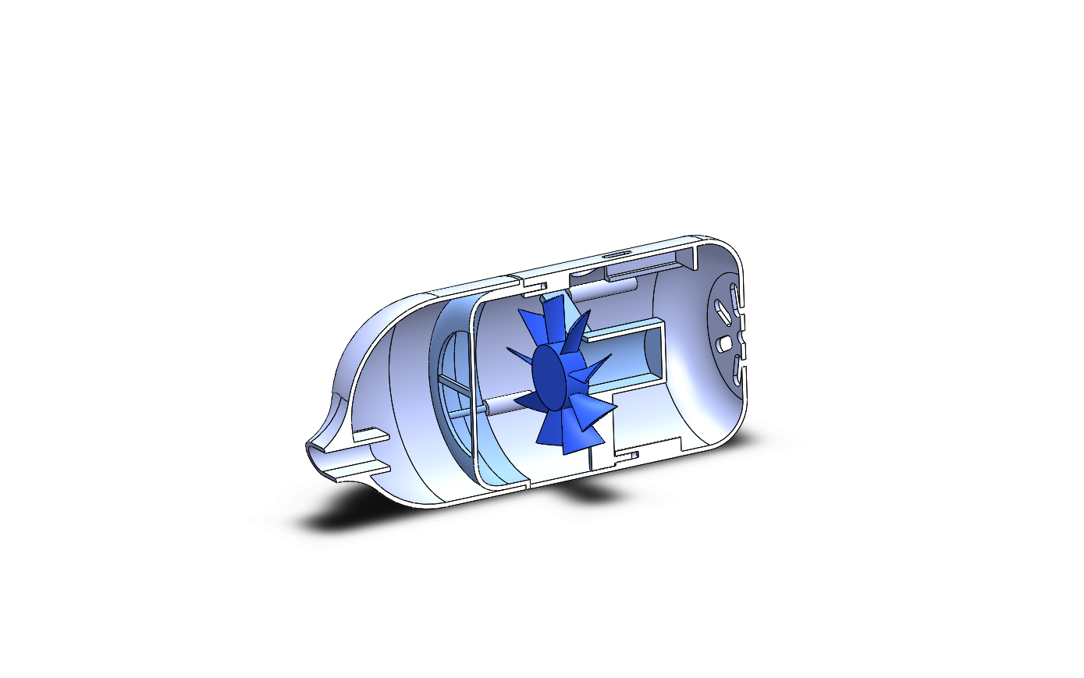

• Shuangyu Lei

• Hao Liang

• Yifan Liu

• Boyuan Zhang

• Yaqing Zhou

# **Abstract**

This section includes information for those readers who will not read the entire document. Although this section appears first in the document, it is usually written last.

It should be one paragraph long (not an introduction) and complete in itself (no reference numbers). It should indicate the general engineering background of your project and state the objectives. The design methodology, measurement techniques, observed facts, key understandings and conclusions must be stated in summary form.

Word count (300-500)

It should include:

* A description of the project background
* A description of the project aim
* A description of the major tasks undertaken
* A description of the measurement techniques employed
* A description of your key observations and physical understanding
* A description of your conclusion
* A description of the significance of your findings.

# **Acknowledgements**

We would like to express our deep gratitude to Professor Qiang Zhang and Professor Irene Wei, for their enthusiastic instructions, valuable encouragement, and constructive suggestions during this research work. We would also like to thank our technical Tas, Jieling Li and Haoquan Zhou, for their guidance and advice in labs. Our thanks are also extended to our communication TAs, Sheng Qiao and Renan Chen. Their willingness to give their time so generously has been very much appreciated. Especially, effects made by each member of Group 12 are greatly appreciated, without which this project would never be so successful.

Table of Contents

**Abstract** 2

**Acknowledgements** 3

**I.****Introduction** 5

**II.****Project Management** 7

**III.****System Design and Assembly** 9

**IV.****Performance Measurement and Numerical Simulation** 10

**V.****Conclusions** 11

**VI.****References** 12

**VII.****Appendix** 12

# **Introduction**

**Background**

In this day and age, the blooming of the Internet industry has brought about more and more office jobs which require sitting in front of the computers for a whole day. Designers, programmers as well as traditional positions like secretaries and teachers all have to face their desks from morning till night. Moreover, with the outbreak and rapid spreading of Covid-19, a horrible virus threatening billions of lives throughout the whole world, many of our lifestyles nowadays have been greatly changed. One of the most significant changes is the emerging trend of staying and working at home, with the development of online meeting software. Desks and computers have become nearly a necessity for everyone. On the other hand, the ravages of the coronavirus, especially the recent deadly outbreak in India [1], are ringing the alarm bells and raising concerns for health and cleanliness problems. Besides working and studying, tables are also where people perform their most daily routines, such as eating and drinking. Thereupon, arises an urgent demand for a clean and dustless working and living place to avoid exposing people to an insanitary environment and causing a series of severe infection and diseases.

But health is not what we only care about. When talking about table cleanliness, there is also another factor that we should not neglect. Various researches have shown that not only does an organized office environment poses a good influence on the construction of organizational identity, but a clean table also contributes to people’s working efficiency and productivity [2]. A tidy desk was found to improve one’s ratings for several qualities: “sincerity, intelligence, ambition, warmth, and calmness,” while in contrast, a messy desk has a negative effect on the perception of others [3]. In short, it is of great importance to own a tidy desktop, considering both healthy and mental influences mentioned above.

According to the benchmarking, however, a great number of desktop dust cleaners on the market are either too expensive or inefficient. Some are limited in their simple function and create too much noise. Others, like those similar to vacuum cleaners, are too large in size and inconvenient for operation. Also, we notice that major products are designed on the basis of radical-flow fans. Therefore, this project aims to create an innovative and user-friendly desktop cleaner, that is, design a small and convenient one supported by an axial-flow fan. The system is composed of a replaceable head so that it can have multiple functions, which means it can clean both large dust on the table and small dust in the keyboards. The study not only provides a model for light and portable desktop cleaner design based on axial-type fan, but can also serve as a reference for further researches on desktop and keyboard cleaners for home and office use.

**Objectives**

* Objective 1: On the basis of an axial-flow fan, design a multifunctional desktop cleaner system (including a replaceable head, a filter and a support) that can clean the keyboard as well so as to minimize the workforce required to clean things manually.
* Objective 2: Evaluate the cleaning performance of the cleaner mainly from the total pressure rise and the effect of suction.
* Objective 3: Optimize the cleaning performance through unifying the directions of the wind, increasing the pressure risen and decreasing the weight based on both virtual simulation and experiment.

**Report Structure**

The abstract part provides a brief but comprehensive overview of this report at the beginning. The acknowledgements express gratitude and respect to the contributors of this report. The introduction presents the context of the work, the desired objectives, and the report structure. Project management, which describes how this team manages this project, shows a concise timetable, budget and bill, the key personnel, and risk assessment. Then system design and assembly section documents detailed methodology and assembly procedure of this project. In the performance measurement and numerical simulation part, the evaluation results and corresponding critical assessment are presented. Last but not least, a concise conclusion, including a discussion about the major parts of this project, will be given. References are at the end of this report.

# **Project Management**

* **Table 1: Project estimated budget**

|  |  |  |
| --- | --- | --- |
|  | Description of Work | Anticipated Costs |
| Task 1 | Brainstorming and benchmarking to set up the objectives of our project, and preparing the proposal |  |
| Task 2 | Doing researches and studying the commercially available products of desktop cleaner, and then do preliminary CAD design. | 75.00 |
| Task 3 | Simulating and analyzing the cleaning performance of our product mainly based on data of pressure risen and rotating rate generated of CFD |  |
| Task 4 | 3D printing the parts and assembling them, and then testing the clean performance by experiment | 80.00 |
| Task 5 | Re-designing the cleaner based on the test results to optimize the clear performance, 3D printing and assembling the cleaner | 80.00 |
| Task 6 | Improving the cleaner by adding some replaceable tip and adjustable rotation speed, 3D printing and assembling the parts | 80.00 |
| Task 7 | Preparing the symposium including preparing the report, poster and so on |  |
|  | Total | ￥ 315.00 |

**Table 2: Bill of Materials**

|  |  |  |  |  |
| --- | --- | --- | --- | --- |
| **Quantity** | **Part Description** | **Purchased From** | **Part Number** | **Price (each) (CNY)** |
| **1** | Deli Desktop cleaner | Tao Bao Vector | Blank18880 | 28.14 |
| **1** | Beisi Desktop cleaner | Tao Bao Vector | mini capsule | 57.52 |
| **1** | Loose-leaf refill | Tao Bao Vector | J38525 striping | 3.36 |
| **2** | DC Motor | Tao Bao Vector | 24000rpm | 5.00 |
| **Total** |  |  |  | **99.02** |

* **Personnel:**
* Shuangyu Lei

-Technical Communicator: Documenting & writing tasks, Research tasks, Design tasks, Reviewing

* Hao Liang

-Coordinator: Planning, Purchasing, Coordinating, CAD work (Solidworks), CFD tasks, Reviewing

* Yifan Liu

-Design & Programming Leader: Research tasks, Design tasks, Programming tasks, Assembling tasks, Testing tasks

* Boyuan Zhang

-Tech Leader: Design tasks, CAD work (Solidworks), CFD tasks, Programming tasks,

Assembling tasks, Testing tasks

* Yaqing Zhou

-Technical Communicator: Documenting & writing tasks, Research tasks, Design tasks, Reviewing

* **Risk Assessment:**

**Technical Risks:**

* The designed size is inappropriate. The support does not fit in the tube or the motor does not fit in the support.
* The rotational speed is unstable or does not reach the expected index.
* The fan does not rotate in the expected direction.
* The fan is too heavy to operate fast and smoothly.
* Solidworks/ANSYS/Arduino goes wrong from time to time.

**Solutions:**

* Measure the parameters of the parts accurately and make appropriate estimates before designing.
* Avoid the fan’s friction with the tube or other possible parts by adjusting its size. Fix the connecting parts of the components to stabilize the operation of the fan.
* Check carefully or use possible wind simulation before 3D-printing.
* Minimize the size as much as possible. Try to hollow out some parts.
* Make sure that a backup is made each time and at least two people are working on the same software and know each other’s progress well.

**Schedule Risks:**

* The design is not finished or the product is not printed out on time.
* The parts brought from e-commerce platform isn’t delivered on time.

**Solution:**

* Make sure that the last product is preserved as a backup plan.
* Always take the delivering time in to consider.

**Safety Risks:**

* When connecting electronic components on the Printed Circuit Board, the positive pole is wrongly connected with the negative one. This may result in an electrical short-circuit and cause an irretrievable damage to the battery and PCB. A fire accident may also occur, posing a threat to the staff’s safety.
* The rotating speed of the motor is up to 24000rps, so it’s likely to cause seriously injuries if operated unproperly.

**Solution:**

* Pay attention to the circuit diagram. Check carefully before connecting the battery.
* Increase the voltage gradually and always be ready to cut off the power in case of any accident when operating.

**Production Risks:**

Inaccurate assembly causes some wire to be broken and leads to avoidable waste.

**Solution:**

Be careful during assembly, manufacturing and packaging.

**Feasibility Risks:**

The results of a group of parameters are ideal in software simulations. But in reality, many other factors like friction, weight and the connection between parts also affect the result. The project objectives are difficult to meet exactly.

**Solution:**

Design fans with multiple sets of parameters as fallback plans. Compare and evaluate their real performances to decide the most ideal one.

# **System Design and Assembly**

This section documents detailed design methodology and assembly procedure for your project. Readers should be able to re-create your system based on this section. You will be graded on the technical completeness of these descriptions.

1. A schematic diagram of your overall system should be provided. The function and technical information about the key components should be explained in detail.
2. You should present your step-by-step design procedure and the theory behind. Some photos, diagrams, and mathematical equations might be necessary.

Some good examples to make good presentation with Figures:

The basic components of the cleaner is shown in the schematic diagram below (Figure 1), including the head, the filter support, the axial-flow fan, the motor support, and the base.

Circuit Support

Filter Support

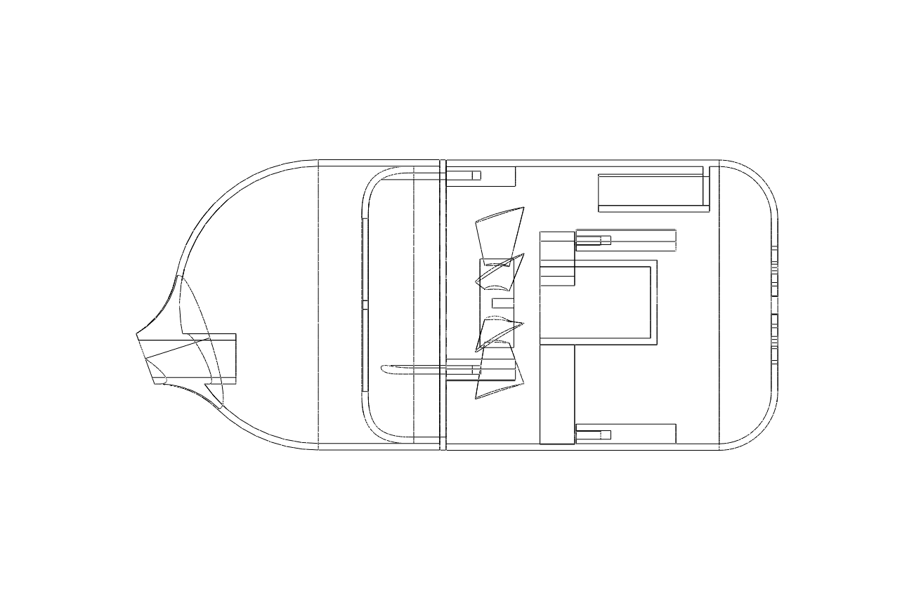

Motor Support

Base

Head

Axial-Flow Fan

**Figure 1: Schematic Diagram of the product**

* **Axial-Flow Fan**

The axial-flow fan is the key part of our design, as is shown in Figure 2. The theory of the design is based on the fundamental characteristics of an axial-flow fan. The rotation of the fan is able to generate a pressure difference, and then a suction force is created. The functional parameters of the fan are listed in Table 3. The total pressure difference is designed to be 200 Pa, and the number of blades is 9. Compared to the other 3 fans, which will be introduced in the next section, this fan is the optimal choice. The axial chord length and the inner diameter are designed to minimize the total volume of the fan.

**Table 3: Functional Parameters**

|  |  |
| --- | --- |
| Functional Parameters | |
| Power | 8.9 W |
| Total pressure diff | 200 Pa |
| Rotating speed | 12000 rpm |
| Mass flow rate | 39.32 g/s |
| Axial chord length | Tip: 1 cm |
| Hub: 0.5 cm |
| Diameter | Outer: 42 cm |
| Inner: 18 cm |

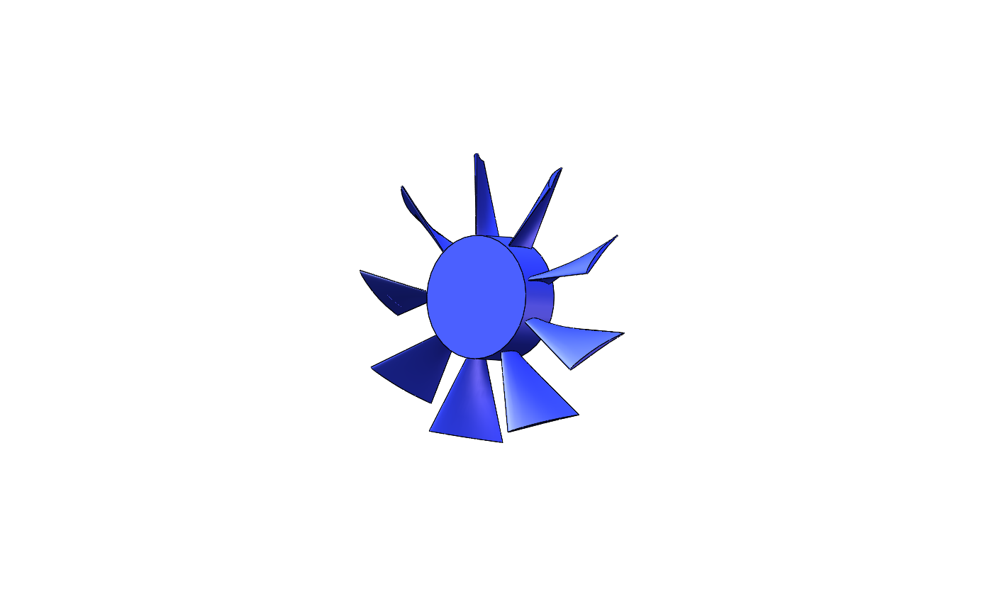

**Figure 2: Axial-Flow Fan**

According to the velocity triangle for the tip shown in Figure 3, the attack angle of the air is not too large so that a stall can be prevented. The twist angle between the tip and the hub is about 35° (Figure 4).

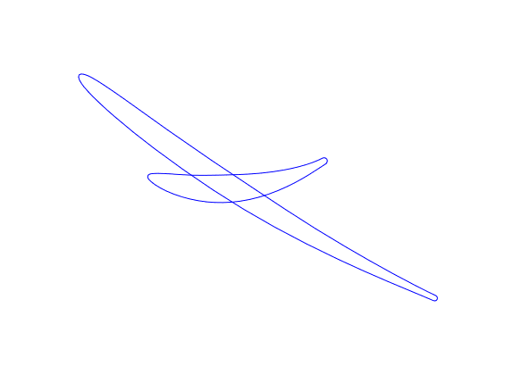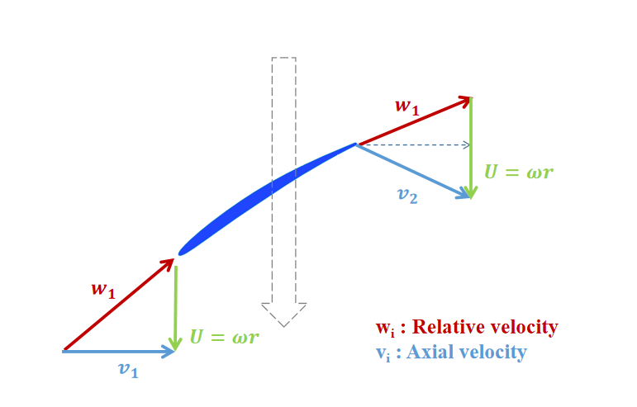

Figure 3: The Velocity Triangle for the Tip Figure 4: The twist Angle

* **Filter Support**

The filter support is where a filter is placed. With a filter, our cleaner can prevent dust from entering the fan, eliminating the potential dangers as well as avoiding secondary pollution. There is sufficient dust store space, and it is easy to clean. The type of the filter we use is 200 meshes, indicating that there are 200 meshes within 1 square inch of filter. Hence, the diameter of a mesh is about 0.075 mm, which is small enough to block almost all kinds of dust in our daily life. Additionally, if the meshes are too dense, the suction performance of the cleaner will be affected. Therefore, a filter of 200 meshes is an optimal choice for our product, ensuring the blocking performance as well as minimizing the disturbance to the suction performance.

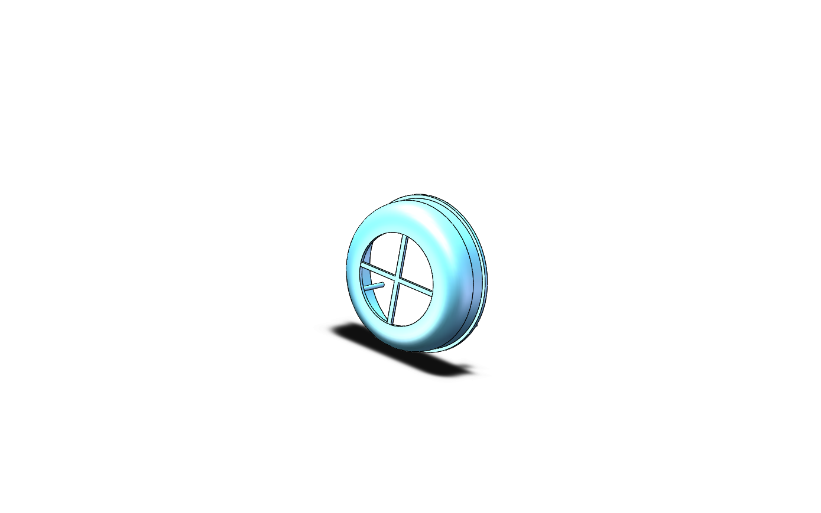

**Figure 5: Filter Support**

* **Head**

The inlet of the head is designed to be curved so that the air can flow in smoothly. The plane where the inlet lies in is parallel to the tangential plane of the semi sphere at the corresponding point so that it can easily clean the dust in the gaps of the keyboard. The length of the inlet is 15.4 mm, and the width is 11.6 mm. Compared to the diameter of the main body, which is 64 mm, the area of the inlet is relatively small. According the continuity equation and the Bernoulli’s equation (Figure 7)

$$v_{1}A_{1} = v_{2}A_{2}$$

$$p_{1} + \frac{1}{2}ρ{v_{1}}^{2} + ρgh_{1} =p_{2} + \frac{1}{2}ρ{v_{2}}^{2} + ρgh_{2} ,$$

where v1 and v2 refer to the velocity, A1 and A2 refer to the area, p1 and p2 refer to the pressure at the inlet and the main body, respectively, and h1 and h2 here can be regarded as the same. The small cross-sectional area at the inlet results in a large velocity and a low pressure. Therefore, the pressure difference between the atmospheric pressure and the pressure at the tip is large, so that a large suction force is generated.

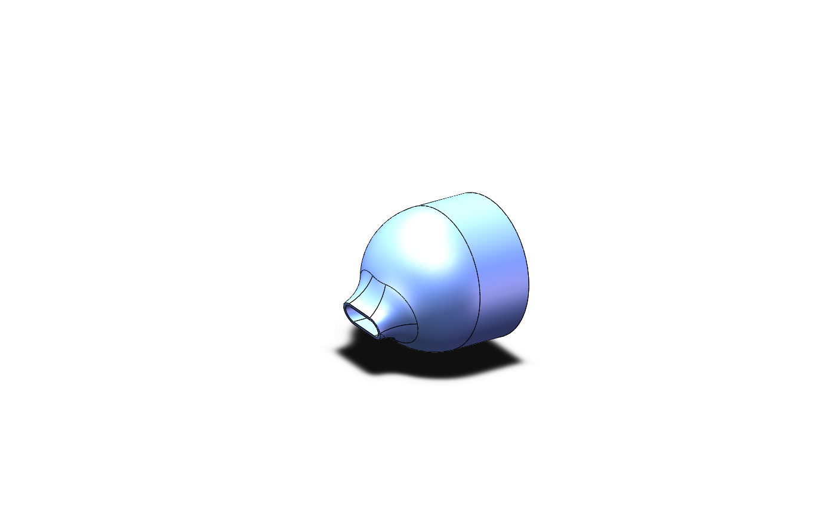

**Figure 6: Head**

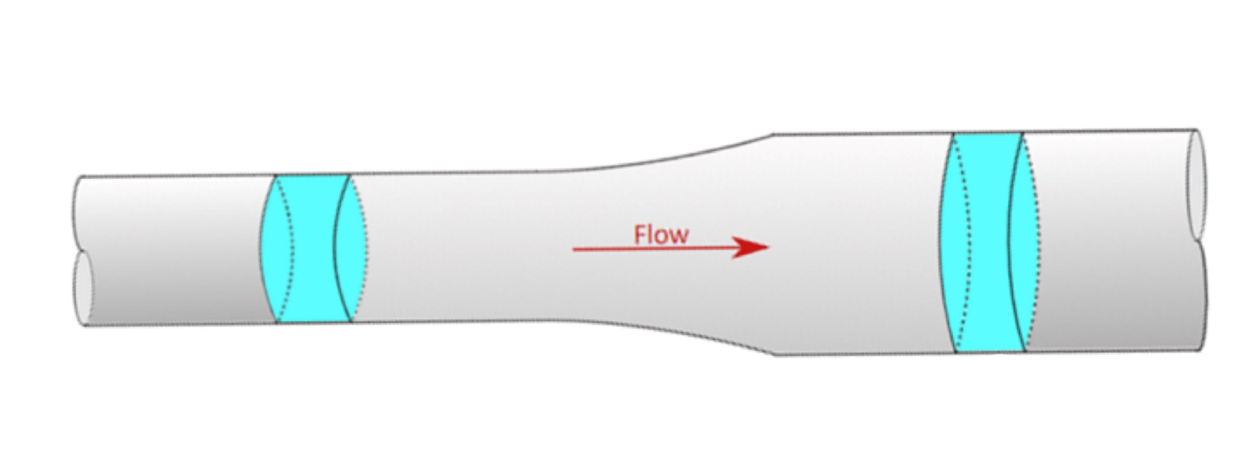

**Figure 7: Visualization of Bernoulli’s Equation**

* **Motor Support**
* **Base**

To make our product portable and easy to hold, the base is designed to be a palm size with diameter 64 mm, which also fits the body diameter of the head. The outlet ensures the air to flow out smoothly, and is designed to satisfy aesthetic purposes.

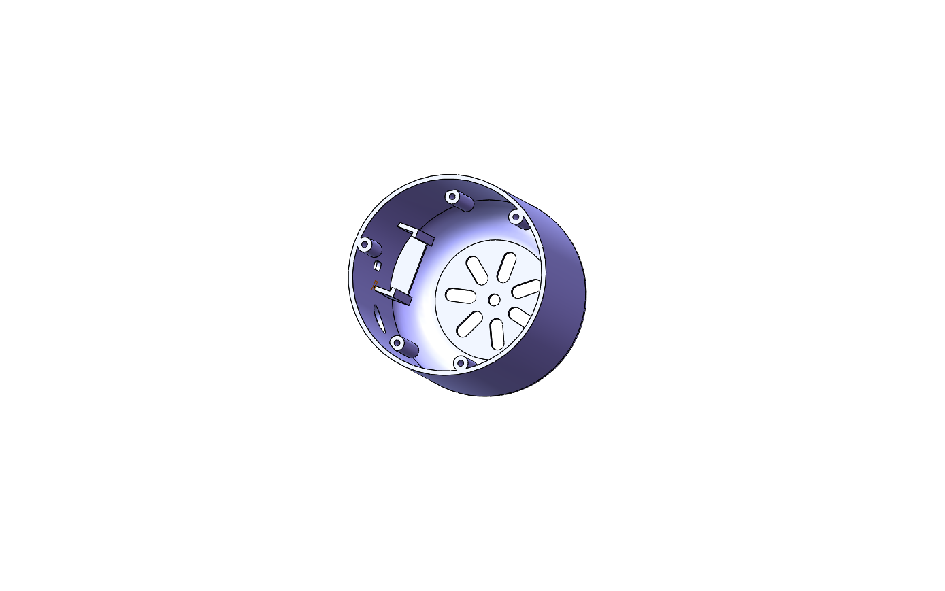

**Figure 9: Base**

* **Circuit System**

A few suggestions for good practices:

* Label font size not excessively smaller or larger than the text font size;
* The parenthetical phrase “(anti-clockwise when looking downstream)” is an example of excessively small font.
* If an image (and often a figure) were to be scaled, do so without changing its aspect ratio.
* Use color schemes but do not be too fancy or arty for an engineering report!

# **Performance Measurement and Numerical Simulation**

In this section you present your performance measurement and simulation results along with supporting text which ensures that the reader understands the data (description of post-processing or evaluation methods, analysis of uncertainties, exposition of tables/figures, correlations).

Next is the most important part of the report – you are expected to assess critically what your results mean, what design implication they might have to the engineering community, and whether they make sense according to what you learned from the engineering lectures. Do not simply repeat in words what is obvious from your figures and tables (this is, sadly, a common mistake).

Refer to a figure or a table by its number, not “figure below” or “table above.” Place a figure or a table close to (often immediately before or after) the “paragraph” of its first mention. By contrast, it is not necessary --- and so DO NOT place a figure or a table immediately after the “sentence” of the first mention; doing so inevitably breaks up a coherent paragraph (consisting of a topic sentence, several sentences of analysis and evidence, and a concluding remark) into several incoherent “paragraphs,” some made of a single sentence.

Figures should have no background, borders, or outlines. Captions are bold with a single tab (no hyphen or other character) between the figure number and figure description. An example Figure is shown in Figure 4.

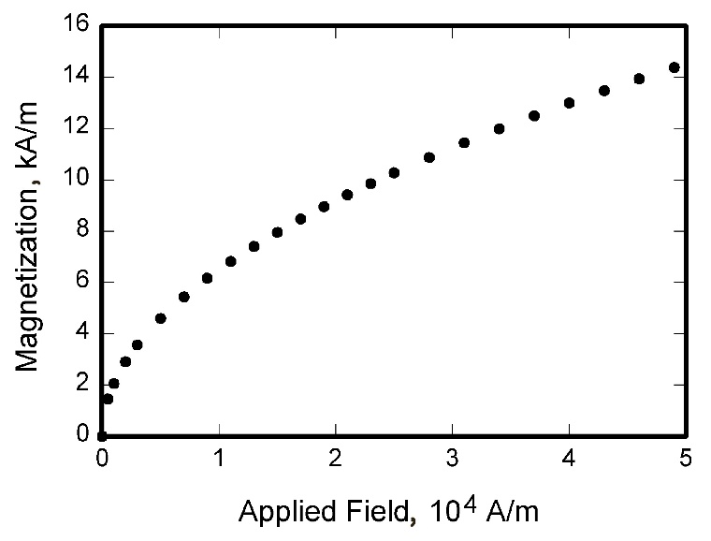

**Figure 4 Magnetization as a function of applied fields.**

Some suggestions for good practice:

* Given the choice, always include a figure rather than a table.
* “Design” your figure concisely: try to plot multiple data sets (whenever appropriate) in the same figure or on one common axis to facilitate comparison and contrast.
* Use markers, line types, colors and labels (encouraged)/legend (convenient) to distinguish between different sets of data on the same figure.
* Use markers for measured results, but lines for modeled ones; do not connect markers with lines without models.
* Plots generated by Excel using its default settings are universally ugly! Spend time to edit or try Matlab.
* Place figure captions below all figures; place table titles above the tables.
* If your figure has multiple parts, include the labels “a),” “b),” etc. below and to the left of each part, above the figure caption.
* Please verify that the figures and tables you mention in the text actually exist.
* Do not label axes only with units. As in Fig. 1, for example, write “Magnetization, kA/m” not just “kA/m.” Do not label axes with a ratio of quantities and units. For example, write “Temperature, K,” not “Temperature/K.”

# **Conclusions**

No more than one page. Although a conclusion may review the main points of the report, do not replicate the abstract as the conclusion.

Start with a concise summary of what you achieved in the project. You should cover the following points:

What were the highlights of the project? How successfully did you meet your objectives? Where and why

did you fail to meet objectives? How did your actual progress match your original plan? Was your estimating of time and resource accurate? With the benefit of hindsight, were there risks for which you failed to prepare adequately? Also discuss any problems which you encountered with e.g. equipment, shortage of resources (expertise/materials/etc.) or events/circumstances external to the project.

Finally, explain how you achieved the learning outcomes for the project, listed in the module description.

You may also offer a concise summary of further opportunities created by your work. Discuss any lessons to be learned for the benefit of future students. *(No need to include these information in your Interim Report)*

# **References**

References should be cited according to IEEE standard publication reference style. Names and locations of publishers should be listed; month and year should be included.

**Example:**

*As Chandrasekhar states, mice share many genetic traits with humans [8].*

Make sure you include at least five peer-reviewed sources. **Baidu, Wikipedia, and similar common databases are not acceptable**. List your references in order of use, and make sure you punctuate your references (and citations) carefully. We recommend using endnote software to help with your formatting.

**References**

[1] Sandip Mandal et al., “Prudent public health intervention strategies to control the coronavirus disease 2019 transmission in India: A mathematical model-based approach.” *Indian Journal of Medical Research,* vol.151, pp. 190-199, Feb-Mar 2020.

[2] Antoine Marie. “The influence of the office on organisational identity construction. The case of open space, clean desk and home-based office.” *Louvain School of Management Working Paper Series*, 2016. [Online] Available: <http://hdl.handle.net/2078.1/185630>. [Accessed: July 4, 2021]

[3] Sarah Sitton. “The Messy Desk Effect: How Tidiness Affects the Perception of Others,” *The Journal of Psychology,* vol.117:2, pp.263-267, July 2010. [Online] Available: DOI: 10.1080/00223980.1984.9923688. [Accessed: July 4, 2021]

# **Appendix**

This is an optional section. Sample content that belongs under Appendices includes programming code, formulae and calculations, manufacturing details and other properties of your parts, other extra test results or efforts for your project.

Note: “optional” content does not mean “raw, unedited” material. Codes should still be annotated (commented), test results should still be formatted (designed for compactness, with table headings or figure axes labels), etc.